1. Solving problems using array functions on rest countries data.

* 1. Get all the countries from Asia continent /region using Filter function

**Output:**

Array(50)

* 1. Get all the countries with a population of less than 2 lakhs using Filter function

**Output:**

Array(63)

* 1. Print the following details name, capital, flag using forEach function

**Output:**

**(250 data)like below**

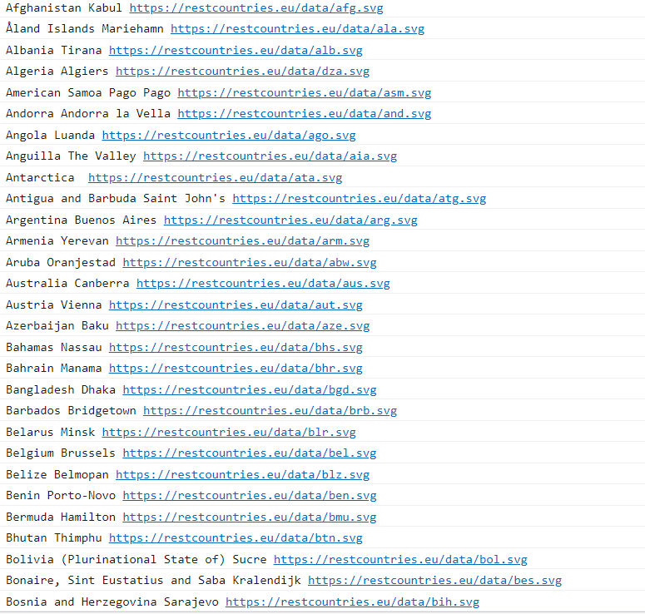

* 1. Print the total population of countries using reduce function

**Output:**

7349137231

* 1. Print the country which uses US Dollars as currency.

**Output:**

